20 Heidelberg Street
CONDER ACT 2906
Webpage: www.lanyonhs.act.edu.au
Email: lanyonHSinfo@ed.act.edu.au
General Enquiries: (02) 6142 1800
Absences: (02) 6142 1815 or lanyonHSstudentabsences @ed.act.edu.au

A/g Principal: Rebecca Cusick
A/g Deputy Principal:
Joh Davies
Jess Klein
School Board Chair:
Neshia Traise
P&C President: Cath Windsor

Upcoming Events

Term 3, Week 3, 5th August: pupil free day
Week 4, 9th August: 7/8 Soccer
Week 5, 15th August: 9/10 Soccer
Week 6, 24th August: Athletics Carnival
Week 8, 9th September: pupil free day

Please note, services and events advertised on the Lanyon High School website or newsletter are not endorsed or associated with Lanyon High School. For more information regarding upcoming school and community events please visit our Facebook and Instagram accounts.
Lanyon High School

@LanyonHighSchool

PRINCIPAL’S MESSAGE

Welcome to Term 3
Lanyon High School acknowledges the Ngunnawal people, the traditional custodians of this land. We would also like to pay respects to the United Ngunnawal Elders Council and to the Elders, both past and present of the Ngunnawal nation. We would also like to extend that respect to other Aboriginal and Torres Strait Islander people in our community.

As we start term 3, it’s great that we can celebrate learnings and experiences from NAIDOC week. We had planned to celebrate NAIDOC Week in week 10 last term but due to staff and student absences we postponed to this term. Throughout week three there are a number of activities to celebrate the histories and culture of Aboriginal and Torres Strait Islander people on the theme of Get Up! Stand up! Show up!, it’s an opportunity to gain new knowledge and a deeper understanding of how we all have a part to play in resolving injustices of the past and in the present. For more information click on the link; https://www.naidoc.org.au/awards/current-theme.

The first part of this term has a strong focus on school transitions for year 6 and year 10 students. It can be a confusing time for students and parents/carers. We will provide you with various updates and reminders about key dates and activities. This week students will receive their letters of offer for their next school and then following that, year 10s will make their subject selections for college. For students who are not going to college, and are not yet 17 years old, parents and carers are reminded that they need to apply for an exemption for schooling to pursue other pathways, such as work or an apprenticeship. Lanyon High School is committed to supporting students in these career paths so please contact the school to receive guidance on completing the application for an Exemption Certificate.

An update on COVID-19 safety measures and mask wearing advice
This week all families should have received an email from the school outlining some updated advice.
While COVID-19 continues to cause some uncertainty in our community our schools and the Directorate are working hard to ensure students continue to access high quality learning regardless of the public health situation. The Education Directorate has updated its ACT Public Schools COVID-19 Management Plan for Term 3. The Plan has been reviewed in consultation with ACT Health. The school will communicate with you if your child is affected. This includes any changes to how they will access their learning (if learning from home) and what that will look like, including for how long.

A reminder about mask wearing
Masks remain an important measure to stop the spread of COVID-19 in our community and in our schools. Alongside other COVID Smart behaviours, masks can help reduce transmission of COVID-19 respiratory illnesses in our schools.
Students in years 7-12 continue to be encouraged to wear a mask at school when in crowded indoors environments, and where physical distancing can’t be maintained. Staff and visitors to schools must also wear a mask indoors when physical distancing can’t be maintained.

For more information read the updated ACT Public Schools COVID-19 Management Plan available on the Directorate’s website.

Please Give Us Your Feedback in August
It is that time of the year when we are all asked to complete our system surveys. Surveys are completed by all staff, both teaching and non-teaching, as well as students and parents/carers. More detailed information will come to you by email. These surveys really help us to see what we are doing well and where we need to improve. I hope all our parents/carers will participate.
Congratulations to our Year 10 Leadership Students
This term our year 10 Leadership class has been busy! Several leadership students supported both Gordon Primary and Charles Conder Primary in running their athletics carnivals. It was lovely to receive the feedback from the teachers at both primary schools that our leadership students have been helpful, supportive of the younger students and excellent role models.
This week, our leadership program was featured on WIN News as ‘School of the Week’. It highlighted the peer support program that our leadership students are running at Charles Conder Primary. The students dealt with last minute changes, and we were all very proud of the way they represented the school. Congratulations Leadership!
You can see the WIN News segment here: https://www.leadstory.com/v/school-of-the-week-202272628

Principal
Rebecca Cusick

CANTEEN EMERGENCY SANDWICHES

As of Term 3, if a student has forgotten their lunch, they can get an Emergency Canteen Sandwich. The student will need to come to the Student Reception and get a form to take to the canteen where they will receive a vegemite or jam sandwich. The canteen will also give them a note to take home letting parents/carers know that the student required an emergency sandwich, and kindly asking for a payment of $3 to be made to the canteen during the following week. Please don’t hesitate to contact the school if you have any questions.

MOBILE PHONE POLICY

MOBILE PHONE USE REMINDER
To support student learning and minimise distractions, students are unavailable to be contacted on personal devices during class time. In the case of an emergency please contact the front office on PH 6142 1800, and a message will be delivered to the student. Alternately students may access their personal devices at break times (11:00 – 11:30am, 1:30 – 2:00pm).

FOCUS – ARTS – LIMELIGHT STUDENT ART EXHIBITION

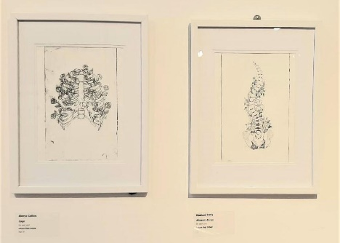

Last night I attended the teachers preview of the 2022 Limelight Student Art Exhibition at the M16 Art space in Griffith. Congratulations to the students who had their work selected for the exhibition based on the theme ‘Found’: Dominic Sutton, Aleeya Collins, Madison Kelly, Aerika Carasig and Ashley Turner Williams. It was a lovely opportunity to view work from Lanyon High alongside other ACT schools.
If you would like to see their work at the gallery the exhibition is open to the public from 29th July to 14th August. https://www.m16artspace.com.au/new-gallery-4. – Review by Julia Schwartz

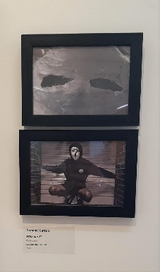

LANYON HIGH P&C MEETING
The Lanyon High P&C meets again on 7 September and is looking for new members. The role of the P&C is to raise funds for activities of the school and provide parental/carer input into the workings of the school. The roles are not onerous. The P&C meets generally three times a year for about an hour with the occasional fundraising activity. If you are interested in being a part of the P&C and having an influence, please contact the Front Office on 6142 1800.

STUDENT SPOTLIGHT

Congratulations to Jeremiah Hill, who represented Lanyon High School at the Australian Interschools Fencing Championships late last term. Jeremiah was the only boys’ representative from the A.C.T, and finished 5th in the boys épée event.

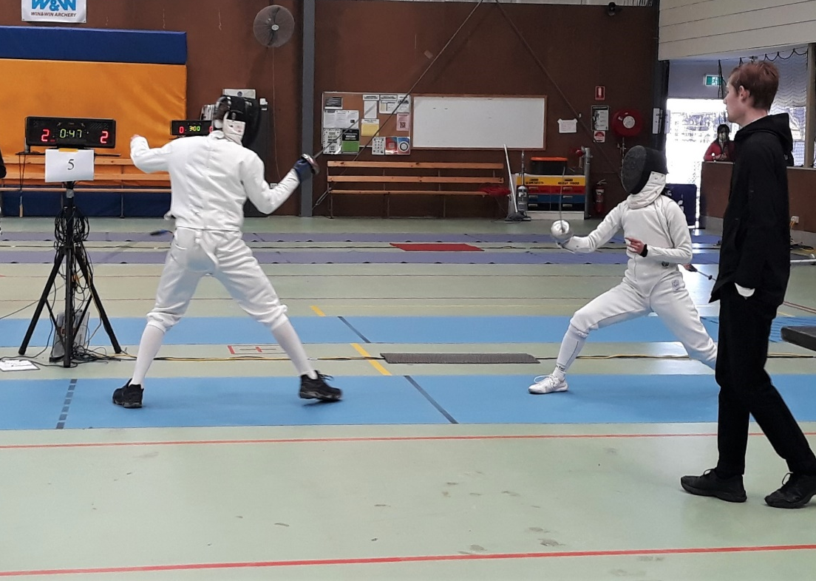

Jeremiah Hill (left). Photo by Laura Hill

CAREER NEWS

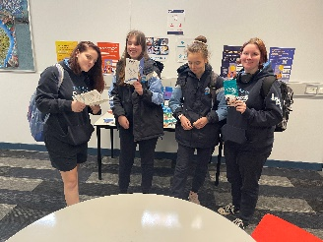
Applications for Semester 2 Vocational Learning Option 2022 are now closed.

Congratulations to those students who were successful with their applications.

Students will attend the VLO one day a week to complete the units of study.

WEX (Work experience)

In the final week of the term, year 10 students participated in Work Experience placements (WEX). The positive feedback that I have received from Host employers was a credit to all students that participated. Well Done Lanyon High! Friendly reminder to students to complete the WEX reflection survey on LH Career service Google Classroom.
If your child was not able to gain a WEX placement, there will be further opportunities to participate in WEX this semester.

College Course Selection and Information Week 4 Monday 8th August
Lake Tuggeranong College and Erindale College will be visiting our school to conduct pre-subject selection interviews and to conduct a college information session on Monday 8th August.
Interested students need to speak to myself (Glenda Johnson) or their year 10 PC teacher to book a time in advance, about the pre- course selection interview time.
Erindale College will be running a parent subject selection information session on Tuesday 23 August and a class selection evening on Wednesday 14 September (TBC).
Please contact Erindale College for further Information on 02 6142 2934.
McBryde Crescent, Wanniassa ACT 2903

First Aid Qualification Tuesday 2nd August HLTAID011 Provide First Aid – ACTWell First Aid (Course Facilitator)
Year 9 & 10 students are offered the opportunity to obtain a First Aid Qualification. Interested students will be required to complete a pre course learning package online, as well as the face-to-face learning component facilitated by ACTWell First Aid. Students must obtain a Unique Student Identification number (USI) to receive the Vocational Education and Training (VET) Qualification before completing the pre-course learning.
Registration information is on the permission notes used to register for the course. You will receive a confirmation email with a link to the online training management portal Training Desk to complete your enrolment and access the online learning (you will require a USI number).
Please complete the online pre-course learning for your course prior to attending. The online theory learning will take about 2-2.5hrs for HLTAID011 Provide First Aid. Limited spaces are available.
A USI can be obtained free of charge at: www.usi.gov.au (ensure students record their USI). Students MUST complete the online pre-course learning PRIOR to Tuesday 2nd August
permission notes were emailed to parents/careers on Thursday 21st July. students can request notes from front office
note and payment due Monday 25th July 2022
2022 ACT Careers EXPO Thursday August 18th
Friendly Reminder to year 10 students
Please Return your signed permission slips to the front office to secure a spot.
COMMUNITY EVENTS

Action Tae Kwan-Do is holding classes at Lanyon High School in Term 3. Classes for people 12+ years and older start at 7:00pm Monday and 6:30pm Wednesdays and are held in a weekly pay-as-you-go format. Participants should wear sports clothes to start with. Any queries can be directed to info.actionkd.com.au, or by calling 0498006006.

